# CS 255 System Design Document Template

## UML Diagrams

### UML Use Case Diagram

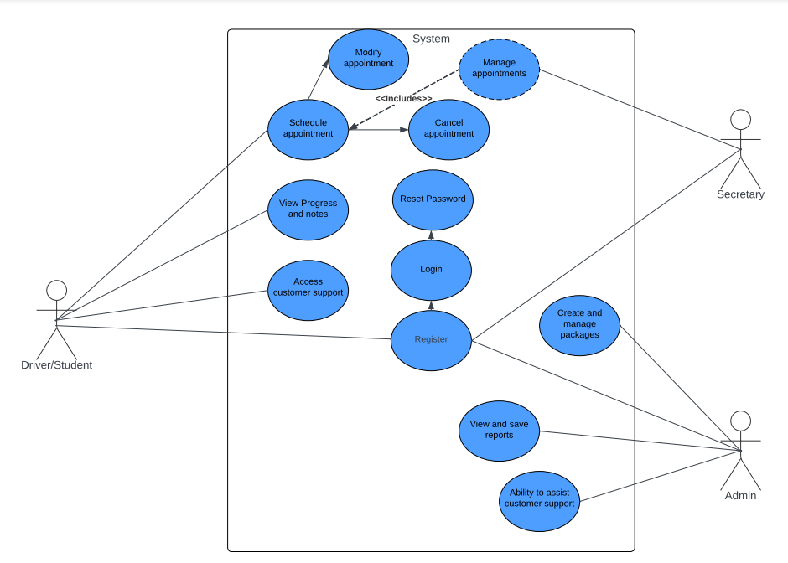

### UML Activity Diagrams

Account registration and Package Creation

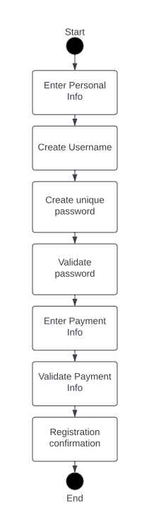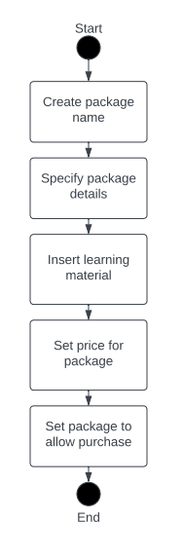

### UML Sequence Diagram

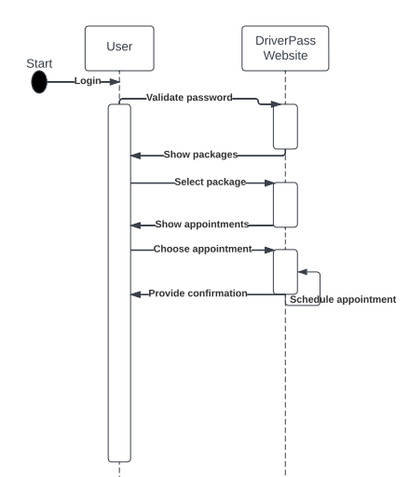

### UML Class Diagram

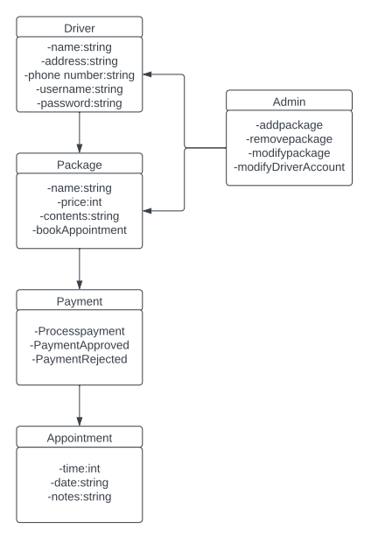

## Technical Requirements

* A device that can access the internet
* Access to the internet
* A developed website
* Payment processor
* Staffing for technical support
* Package content for students